General Introduction :
the project was inspired by the trivy suply chain attack on mars 2026 i decicded to investigate the accident the security immitation and try to build a secure system with best practises and with focus on securing our tool
The goal is to build a full secure system with applying owasp guides and CIS Benchmarks , best security practices full maturity etc..

We will have several security layers to ensure a robust system..note: I could’ve renforce more with falco scanning / audit loggingg and more observability however due to not enough ressources I decided to not doing it

Layer 1 — Infrastructure/OS hardening
Ubuntu hardening, kubeadm cluster hardening,
Layer 2 — Kubernetes workload security
securityContext, RBAC, network policies,
Layer 3 —CI-CD security
Image scanning, signed images, SBOM, secrets management branch protection rules ..

the project was inspired by the trivy suply chain attack on mars 2026 i decicded to investigate the accident the security immitation and try to build a secure system with best practises and with focus on securing our tool

1.1Trivy Supply Chain Attack
what does Trivy actually do in a pipeline?
When a company sets up CI/CD, they add Trivy as a step that automatically scans their code/images for vulnerabilities every time someone pushes code. To do its job, Trivy runs inside the pipeline, which means it has access to whatever that pipeline has access to — cloud login keys, GitHub tokens, database passwords, Kubernetes access, etc. Trivy itself doesn't need all that, but it's sitting right next to it.

How did the attackers actually break in? (step by step)
- They found a security bug in Trivy's own automation (a GitHub Actions misconfiguration) and used it to steal a secret key (a token) that had permission to publish new Trivy code.
- Aqua Security (the company behind Trivy) noticed and rotated (changed) the secret keys — but they didn't change all of them properly. Some old stolen keys still worked.
- Three weeks later, the attackers came back using those leftover stolen keys.
- With that access, they did something sneaky: in Git, a "version tag" like v0.35.0 is supposed to permanently point to one specific piece of code. The attackers force-moved those tags to point to different, malicious code instead — without changing the tag name. So if your pipeline said "use trivy-action@v0.35.0", you were now silently getting malicious code, even though nothing in your config changed.
- That malicious code was designed to run first, quietly steal all the secrets available in that pipeline, send them to the attacker's server, then delete all evidence and run the real Trivy scan normally — so your pipeline looked 100% fine, green checkmark, no errors, nothing.

Now, what did they steal, concretely?
Whatever secrets existed in the pipeline at the moment it ran the poisoned tool. Examples:
- GitHub tokens (lets attacker push code as you)
- AWS/cloud credentials (lets attacker access your cloud account)
- Kubernetes tokens (lets attacker access your cluster)
- SSH keys
- Database passwords
Those were some of the fixes to avoid who who got compromised
Fix 1 — Update to a clean version
Simple: stop using the poisoned versions, switch to ones confirmed clean.
Fix 2 — Never trust a "tag" again, trust a fixed commit ID instead
This is the most important lesson. A tag (like v0.35.0) can be moved by anyone with write access — that's exactly what happened. A commit SHA (a long fixed hash like a1b2c3d4...) can never be moved or changed — it's permanently tied to one specific, unchangeable piece of code.
Fix 3 — Block the attacker's server
The stolen data was being sent to a fake look-alike domain (aquasecurtiy.org — notice the swapped letters, mimicking aquasecurity.org). Blocking that domain on your network stops any leftover infected systems from successfully sending data out.
Fix 4 — Check if you were actually hit
Look for specific telltale signs the attackers left behind (a weird folder name, a malicious file at a specific path) to know if you were compromised.
Fix 5 — Assume the worst and reset everything
If your pipeline ran during that exact window, treat every secret it had access to as already stolen, and reset/replace all of them — don't wait to "confirm" theft, just assume it happened.
Fix 6 — Don't trust cached copies either
Some systems cache (locally store a copy of) downloaded tools/images to speed things up. Those caches might still be holding the malicious version even after the official source was cleaned. So even your local cache needs to be wiped or bypassed

In general to avoid this we need to use immutable github version put the tool in an isolated network namespace .. use The principle of least privilege .. etc I discovered it was not easy not all tools have immutable versions not all tolls can work without internet connection and some need high priviliged accses and securing around 7 ou 8 tools was a lot of work for one persone however I tried the best I can do

Layer 1 Infrastructure/OS hardening

.
Securing Lynis itself
I wanted to use github immutable version was not enabled on lynis ..

Lynis is actually lower-risk than Trivy in one key way: it doesn't typically run inside a CI/CD pipeline with cloud secrets attached. It runs locally on a server to audit that server. But it still deserves real scrutiny, since it runs with elevated (root) privileges to inspect your system. Here's how to apply the lesson from Trivy to it.
Download. Pin to an exact, verifiable version + gpg verification
curl -L https://github.com/aquasecurity/trivy/releases/download/v0.50.1/trivy_0.50.1_Linux-64bit.tar.gz -o trivy.tar.gz
curl -L https://github.com/aquasecurity/trivy/releases/download/v0.50.1/trivy_0.50.1_Linux-64bit.tar.gz.sig -o trivy.tar.gz.sig
gpg --verify trivy.tar.gz.sig trivy.tar.gz
this will
Protects Against | Does NOT Protect Against
Tampered binary (modified after signing) | Aqua Security's own signing key being compromised
Man-in-the-middle swapping the download | A vulnerability introduced before the release was signed
Fake/unofficial builds
Registry compromise (binary was modified after upload)

This will protects me from accidentally getting a newer, possibly-compromised release without you knowing.

5. Verify integrity over time, not just at install
I Set up a simple check so i notice if the Lynis binary/files and the install/config files Lynis uses. were tampered with after installation
Hash the entire install directory (recursively) as your baseline, not just the executable:
bash
find /usr/local/lynis -type f -exec sha256sum {} \; > baseline.txt
Then re-check the whole tree, not one file.

bash
# Generate and store a baseline hash after verified install
sha256sum /usr/local/lynis/lynis > /etc/lynis-baseline.sha256

# Periodically re-check
sha256sum -c /etc/lynis-baseline.sha256
email alert if something get wrong
we decided to move on with the seconde approch as we pplan to mitigate against the possible malicious version
If the hash ever changes without you deliberately updating it, that's your signal something modified the tool.
/etc itself isn't inherently "safe" in the sense of being protected from root — if an attacker gets root (which is exactly the scenario you're defending against), they can modify anything in /etc, including your baseline hash file. So storing the hash at /etc/lynis-baseline.sha256 protects against accidental changes or a non-root compromise, but not against a full root-level attacker, who could simply update both the binary and the baseline hash together, and your check would pass even though the tool is now malicious

One solution is to use a write-once storage location however we will stick with only hashing

Network Namespace
The Core Concept
Linux can give a process its own isolated copy of network resources — interfaces, routing tables, firewall rules — completely separate from the main system. A process running inside that isolated copy simply cannot see the real network at all.
Step by Step
bash
ip netns add lynis-ns
This creates a new, empty network namespace called lynis-ns. By default it has:
- No network interfaces (no eth0, no wlan0, nothing)
- No routing table
- No DNS configuration
- It is, networking-wise, a blank slate
bash
ip netns exec lynis-ns lynis audit system
This runs the lynis audit system command inside that namespace. Lynis still has full root privileges for everything it actually needs — reading files, checking permissions, inspecting configs — because namespaces only isolate networking, not filesystem access or root capability.
Why Root Doesn't Matter Here
Normally, root can bypass almost any restriction — that's exactly why your earlier question ("but Lynis needs root") broke the UID-based approach. But a network namespace isn't a permission — it's a resource. Root inside lynis-nsstill has zero network devices to use, the same way being the most powerful person in a room with no doors doesn't let you leave the room. There's nothing to escalate into.

After securly scanning we got Test Count Breakdown
Metric | Value
Total tests available | 458
Tests performed | 256
Tests skipped | 202
Completion rate | ~56%

In the report we got 4 warning with 3 False postive
We rewrite the scan
Modifiy monitor.sh to a simpler way

apt-get update, apt-get upgrade, apt-get dist-upgrade what is the difference

Host OS (Ubuntu) — enable unattended upgrades:
We configured automatic security updates
1. # Install and enable automatic security updates
2. apt install unattended-upgrades
3. dpkg-reconfigure unattended-upgrades
4. # Now Ubuntu auto-applies security patches every night

Installing Fail2Ban blabla bla anti brute force attacck
installing kube bench
The standard tool for this is kube-bench (by Aqua Security) for the Kubernetes cluster layer, and a separate OS-level scanner for Ubuntu itself.
== Summary total == (with no ns)
79 checks PASS
2 checks FAIL
50 checks WARN
0 checks INFO

== Summary total == (with ns)
78 checks PASS
4 checks FAIL
40 checks WARN
0 checks INFO

Audit loggin enabled…
Etcd encryption enabled
enable tls client certificate auth
securing etcd..

test
What this confirms
error:0A00045C:SSL routines::tlsv13 alert certificate required
etcd rejected the connection because you didn't present a valid client certificate. This means TLS client certificate authentication is properly enforced on etcd — exactly what we hoped to confir
How to test etcd reachability from another machine
Run this from any other machine on your network:
bash
1. nc -zv 192.168.1.27 2379
2.
- -z → just check if the port is open, don't send data
- -v → verbose, shows the result clearly
Testing an actual etcd API call (not just port openness)
To see if etcd will actually respond to a real request (this checks whether TLS client certs are being enforced):
1. curl -k https://192.168.1.27:2379/version
2.
- If TLS client cert auth is properly enforced, you'll get an error like certificate required or the connection will be rejected
- If it responds with actual version info without requiring a certificate, that's a serious problem — it means etcd is answering requests with no authentication at all

Is it bad that nc succeeded?
Partially bad — it's an exposure, not a breach. It means:
- Any device on your LAN can confirm etcd's port is open (useful information for an attacker doing reconnaissance)
- Any device on your LAN can attempt to talk to etcd

But it does NOT mean:
- Anyone can actually read/write data in etcd
- Anyone can steal your Secrets just from this

What it actually results in
The real consequence of nc succeeding (port reachable) is:
- Attack surface exists — a port that shouldn't need to be reachable from that machine, is. This is unnecessary risk, even if currently blocked by certificates.
- If certificates were ever weak, missing, or misconfigured, this open port would be immediately exploitable. Right now, your curl test proved certs are correctly required — so this specific risk is currently mitigated, but only by that one control.
- If someone steals a valid client certificate (e.g., by compromising a node with cert files on disk), this open network path is what lets them use that stolen certificate to reach etcd from anywhere on the LAN, not just from the control-plane node itself.
Adding iptables to allow only from controle plane ip
1. sudo iptables -A INPUT -p tcp --dport 2379 -s 192.168.1.27 -j ACCEPT
2. sudo iptables -A INPUT -p tcp --dport 2379 -j DROP
3.
Enabling encryption at rest for the etdc.

Layer 1 — diagram os lynis kube bench in isolted ns sha cronjob files verification scripts file unattended upgrade..

Layer 2 — Kubernetes workload security
securityContext, RBAC, network policies kyverno etc..
Create the app introducing it architecture language framework secrets… our vulnerabilites for testing
App diagram simple one framework secrets vulnerabilites
Creating simple docker files kubernetes overwrite security things we will reschudule it later..
Using nginx unprivilged

Why does plain nginx still exist, then if there is nginx unpriviliged?
Because most people running nginx aren't running it inside Kubernetes with runAsNonRoot enforced. Plain nginx running directly on a VM, or in a simple Docker container without strict security contexts, has no reason to avoid root — it's the traditional, decades-old default, and root works fine there. The non-root requirement is specifically a Kubernetes security best-practice thing (and container-security-in-general thing) — not a general nginx thing.
So nginx-unprivileged isn't a replacement for nginx, it's a variant for one specific situation: containerized environments (mainly Kubernetes) where you're intentionally locking down privilege escalation. Someone running nginx as a normal system service on Ubuntu, or in a Docker container with no particular security hardening, has zero reason to reach for it — root works, nothing forces the switch.
Representing our cluster architecture dev prod ns tainting toleration process etc..
i
Project architecture changing creating namespaces labeling nodes , tainting tolerating configuring kyverno for auto routing mutating
Introducing apps we installed sonarqube nexus defectdojo etc..
Simple cluster diagram with each tool port : this diagram is for introducing what a devops engineer will use
notice we couldn’t secure everything more complicated work we just focused on securing only those who what we used
node dedication or workload isolation
give Kyverno's controllers (admissionController, backgroundController, cleanupController, reportsController) their own tolerations directly, since the automatic mutation policy's scope never included them.
Applying network policies in the correct ns
We need to add notes in kyverno that we need to exclude things like postegers for exemple
Introducing kyverno policies .. explaining them..
Applying kyverno policies..

Introduction the architecture ..

Preparing kubernetes yaml files
Presenting basic files architecture
k8s/k8-auth-service/auth-service.yaml, the pod loads configuration from three layers using envFrom:
- mindgrid-config (Shared ConfigMap): Contains global settings used by all services (DB_HOST: postgres, DB_PORT: 5432, ALLOWED_ORIGINS, etc.).
- auth-service-config (Service-Specific ConfigMap): Contains variables unique to this service (e.g. PORT: 3001). Similarly, puzzle-service has PORT: 3002, and leaderboard-service has PORT: 3003.
- mindgrid-secrets (Secret): Contains sensitive credentials (DB_PASSWORD, JWT_SECRET, etc.).
This separation lets each microservice run on its own port without hardcoding values in code or Dockerfiles!
Explaining files folders etc..
Pods diagram architecture application lvl

Explaining pvc we used local path provisonner
Statfulset configuring it

Antiaffinity rules
Adding liveness and probiness
postgres-retain → used specifically for your database, where losing the data would be a disaster — so it's set up to be extra safe and never auto-delete, even by accident
reclaimPolicy: Retain
installing rancher.io/local-path / nginx fabric gateway..

simple presentation of the cluster architecture

showing the working app
starting improvement after testing

Starting improving security best practise from owasp of the yaml files
Writing digests.. The problem with tags: nginx:1.25 looks fixed, but tags are mutable pointers. Someone can push a new image and reassign that same tag to different content tomorrow. Your deployment YAML says nginx:1.25, but what actually gets pulled can change without you editing anything.
What a digest looks like:
setting rate limit
testing
for i in {1..30}; do
curl -s -o /dev/null -w "%{http_code}\n" -X POST http://192.168.1.27:32578/api/auth/login \
-H "Content-Type: application/json" \
-d '{"username":"test","password":"wrong"}' &
done
wait

Configuring non root users // dropping all capabilites
Setting up readOnlyRootFilesystem: true and setting up folders expectations..

Creating service account with automountServiceAccountToken: false is
We need testing verifiying service accounts exist / have no roles etc..
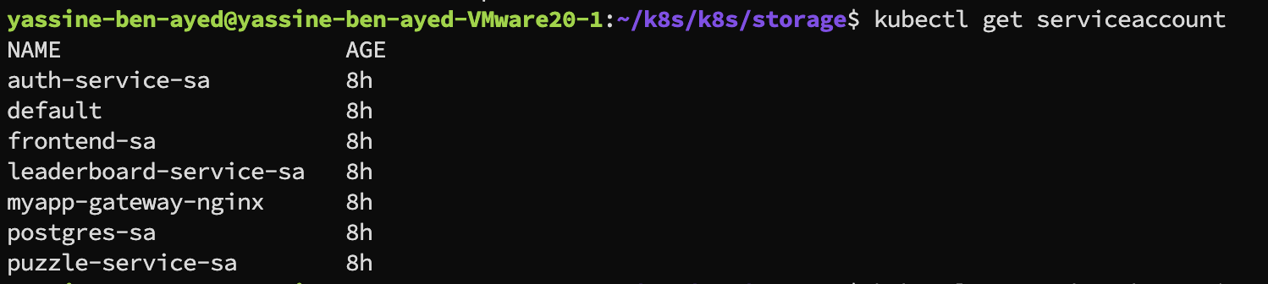

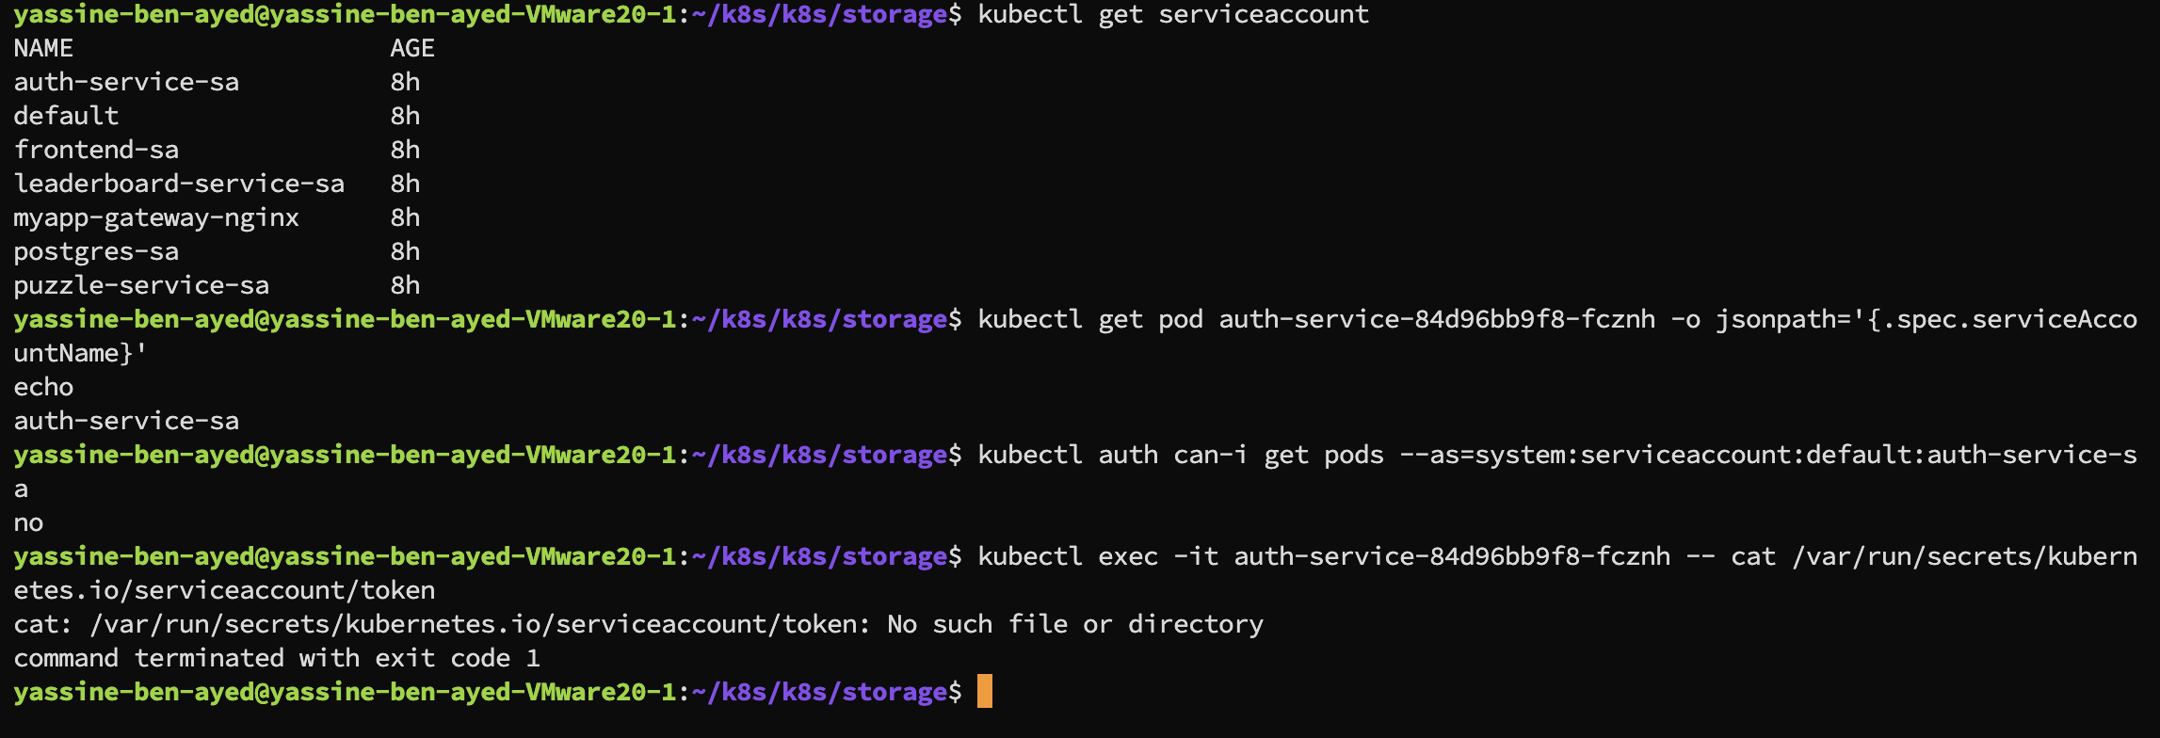

Writing networking policies :
Deny all as a best practise
Allowing only required
Testing ..

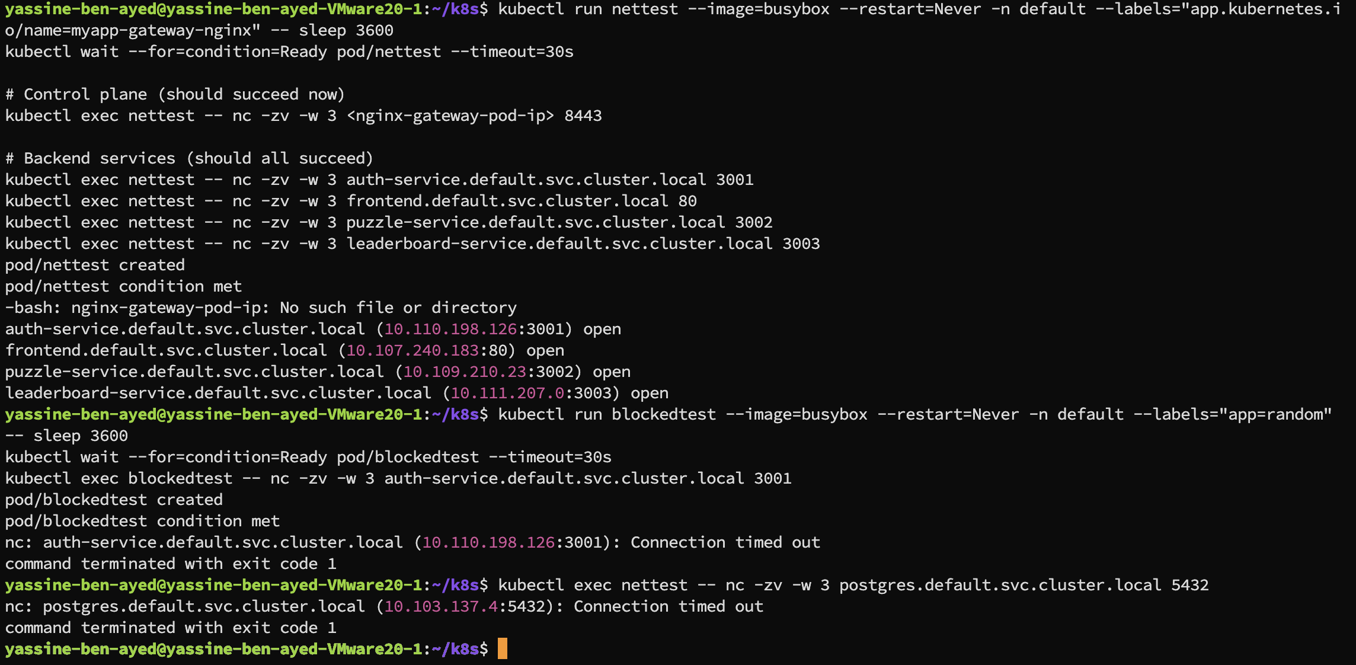

Since readiness and probiness need to be called by the kubelet we allowed only ip of the nodes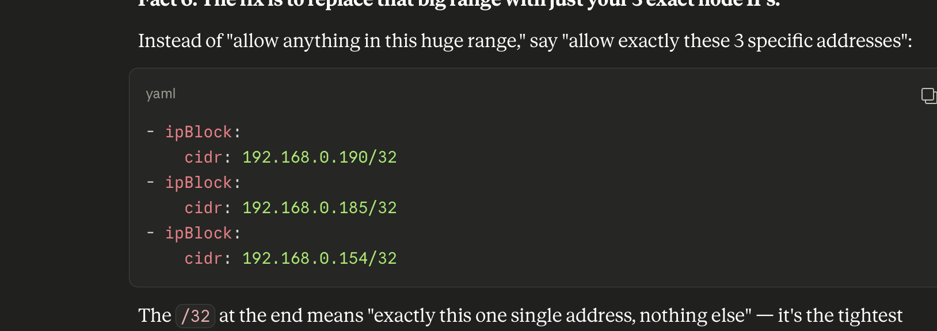

Network policies diagram..

Installing kubescape
Installing kubescape operator
Testing if kubescape can do data exfiltraion

kubectl get pods -n kubescape -o yaml | grep -i "server\|backend\|account\|url"
Think of it as two commands chained together with a pipe (|) — the output of the first becomes the input of the second.
Part 1: kubectl get pods -n kubescape -o yaml
- kubectl get pods = "show me the pods"
- -n kubescape = "specifically in the kubescape namespace"
- -o yaml = "don't just give me the summary table — give me the full raw configuration of every pod, in YAML format"
Normally kubectl get pods shows you a short table (name, status, age). Adding -o yaml instead dumps everything— every environment variable, every mounted volume, every argument passed to the container, every image name. It's the entire blueprint of each pod.
Part 2: | grep -i "server\|backend\|account\|url"
- | = "take that huge YAML output and pass it to the next command instead of printing it directly"
- grep = a search tool — it scans text and only prints lines that match what you're looking for
- -i = ignore uppercase/lowercase differences (so it catches "URL", "Url", "url" all the same)
- "server\|backend\|account\|url" = search for any line containing one of these words: server, backend, account, or url
Why I Searched for Those Specific Words
I was looking for hints of an external destination hiding in the pod configs — things like:
- A line saying KUBESCAPE_SERVER_URL=https://api.kubescape.cloud
- A backend: field pointing somewhere outside your cluster
- An account: or API token tied to a cloud service
If Kubescape were sending your data somewhere, it would typically need a URL or server address configured somewhere in its pod definition to know where to send it.
Your Idea | Does It Stop Exfiltration? | Why
Egress NetworkPolicy | ✅ Yes — this is the real answer | Even if malicious code runs inside the pod and reads every secret in memory, it physically cannot send that data anywhere if egress is blocked. This is the only control on your list that stops the actual exfiltration step.
Root read-only secrets file | ⚠️ Barely helps here | If Kubescape's pod has RBAC permission to get/list secrets via the K8s API (which it needs to scan them), file permissions on disk are irrelevant — it's not reading a file, it's calling the API. Root-vs-non-root only matters for host/container escape scenarios, not API-based secret reads.
Encrypting secrets at rest (etcd encryption) | ❌ Doesn't help at all against this threat | Etcd encryption protects secrets from someone reading etcd's disk files directly. But Kubescape reads secrets through the Kubernetes API, which automatically decrypts them for authorized callers. If Kubescape's ServiceAccount has RBAC access to secrets, encryption is completely transparent to it — it sees plaintext either way.
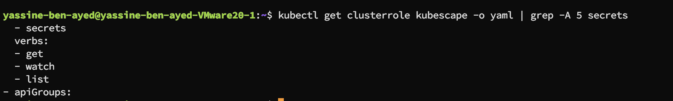
Any code running inside the Kubescape pods — legitimate or malicious — has API-level permission to read every secret in your cluster (assuming ClusterRoleBinding to all namespaces, which is typical). This is by design, since Kubescape's compliance checks include things like "is this secret referenced insecurely," which sometimes requires inspecting values.

What Each Component Actually Needs
Component | Talks To | Why
operator, kubescape, kubevuln | Kubernetes API server only | They fetch pod/secret/config data through the API, not by connecting to pods directly
node-agent | Local node's kubelet + container runtime (on the same node), not other pods | It inspects the node it's running on (processes, files, runtime behavior) — this happens locally on the host, not over pod-to-pod network calls
storage | API server (exposes an aggregated API) | Just serves data back to other Kubescape components via the API

Writing egress file for securing kubescape from data extrafiliation..

Writing seccomp
Kubescap final scan score
The compliance score is calculated by multiplying control failures by the number of failures against supported compliance frameworks. Remediate controls, or configure your cluster baseline with exceptions, to improve this score.

* MITRE: 85.89%
* NSA: 88.30%

View a full compliance report by running '$ kubescape scan framework nsa' or '$ kubescape scan framework mitre'

Changing project name in the cv

Layer 3 —CI-CD security
Image scanning, signed images, SBOM, secrets management branch protection rules ..
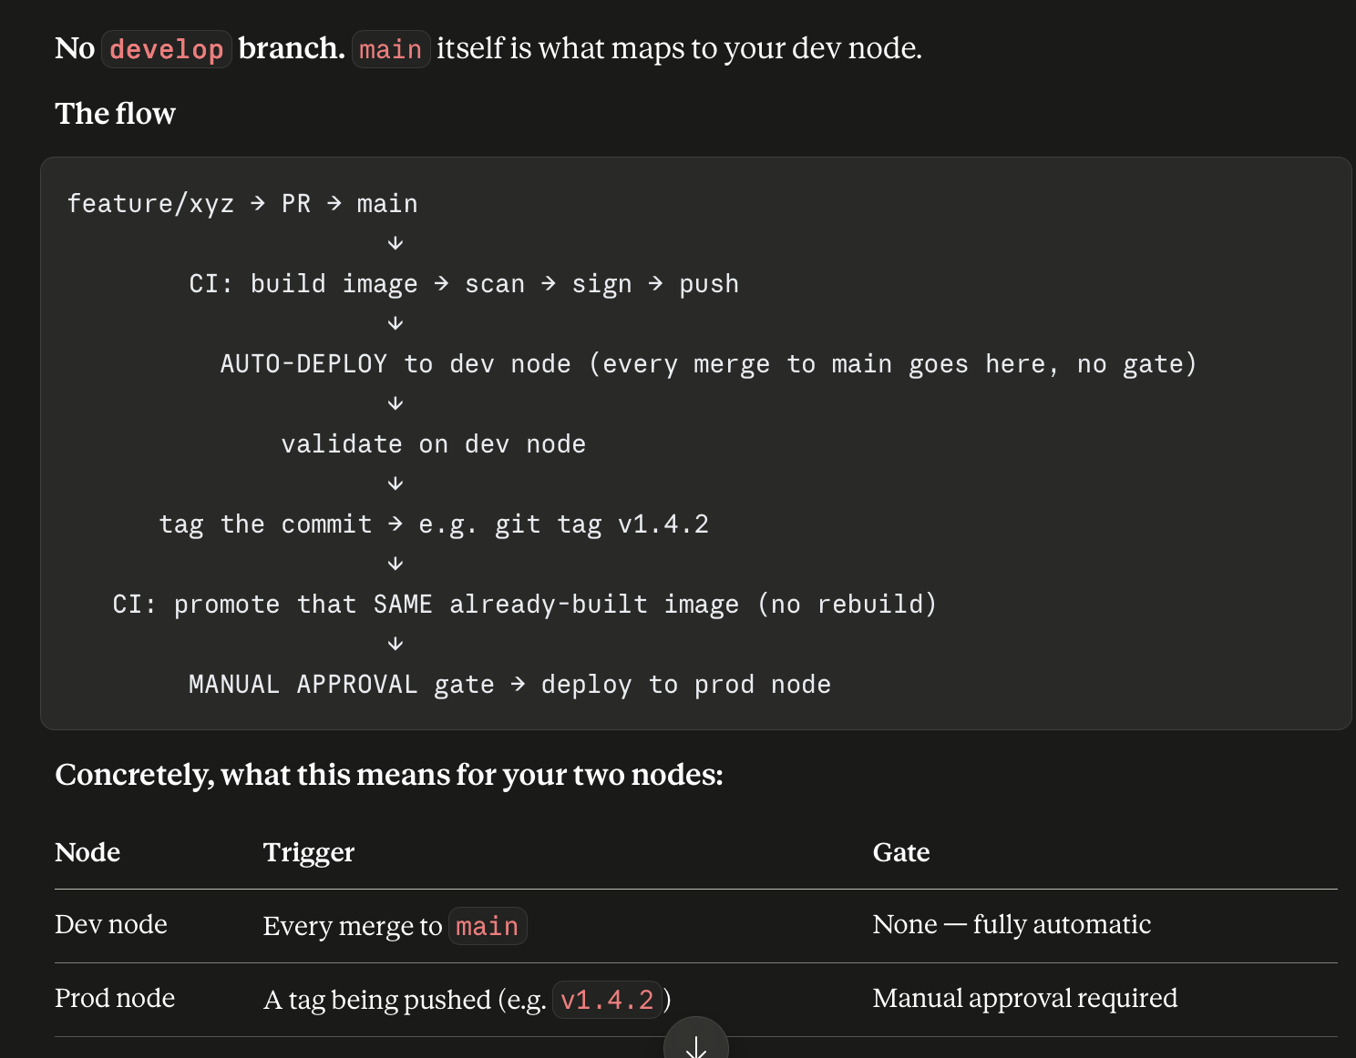
Explaining the workflow the branching strategie used (nzidouha fel cv)
Securing the ci cd rbac service account tokens seperated jobs..
allowing Branch protection rules ( need updated)

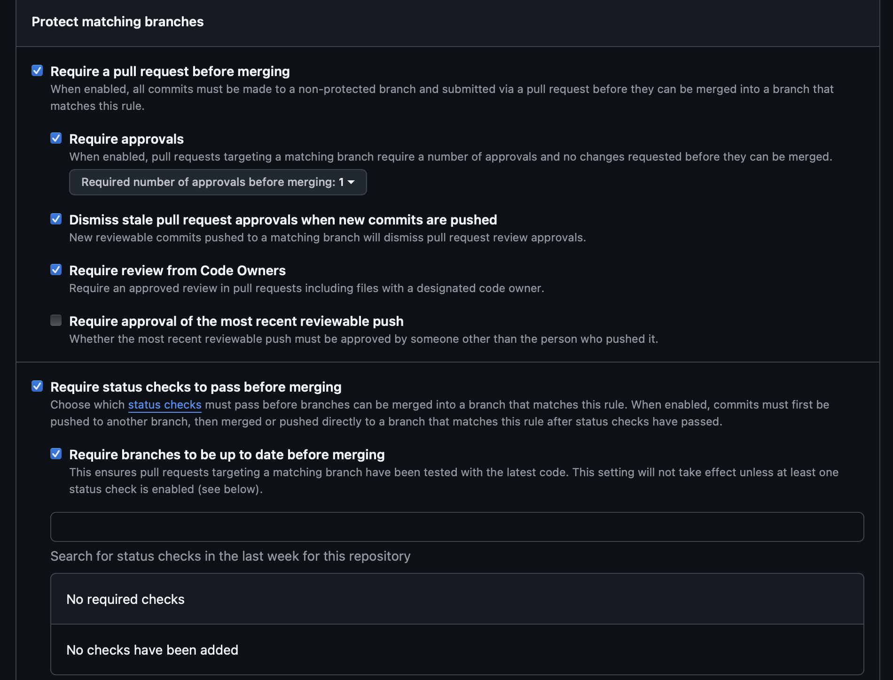
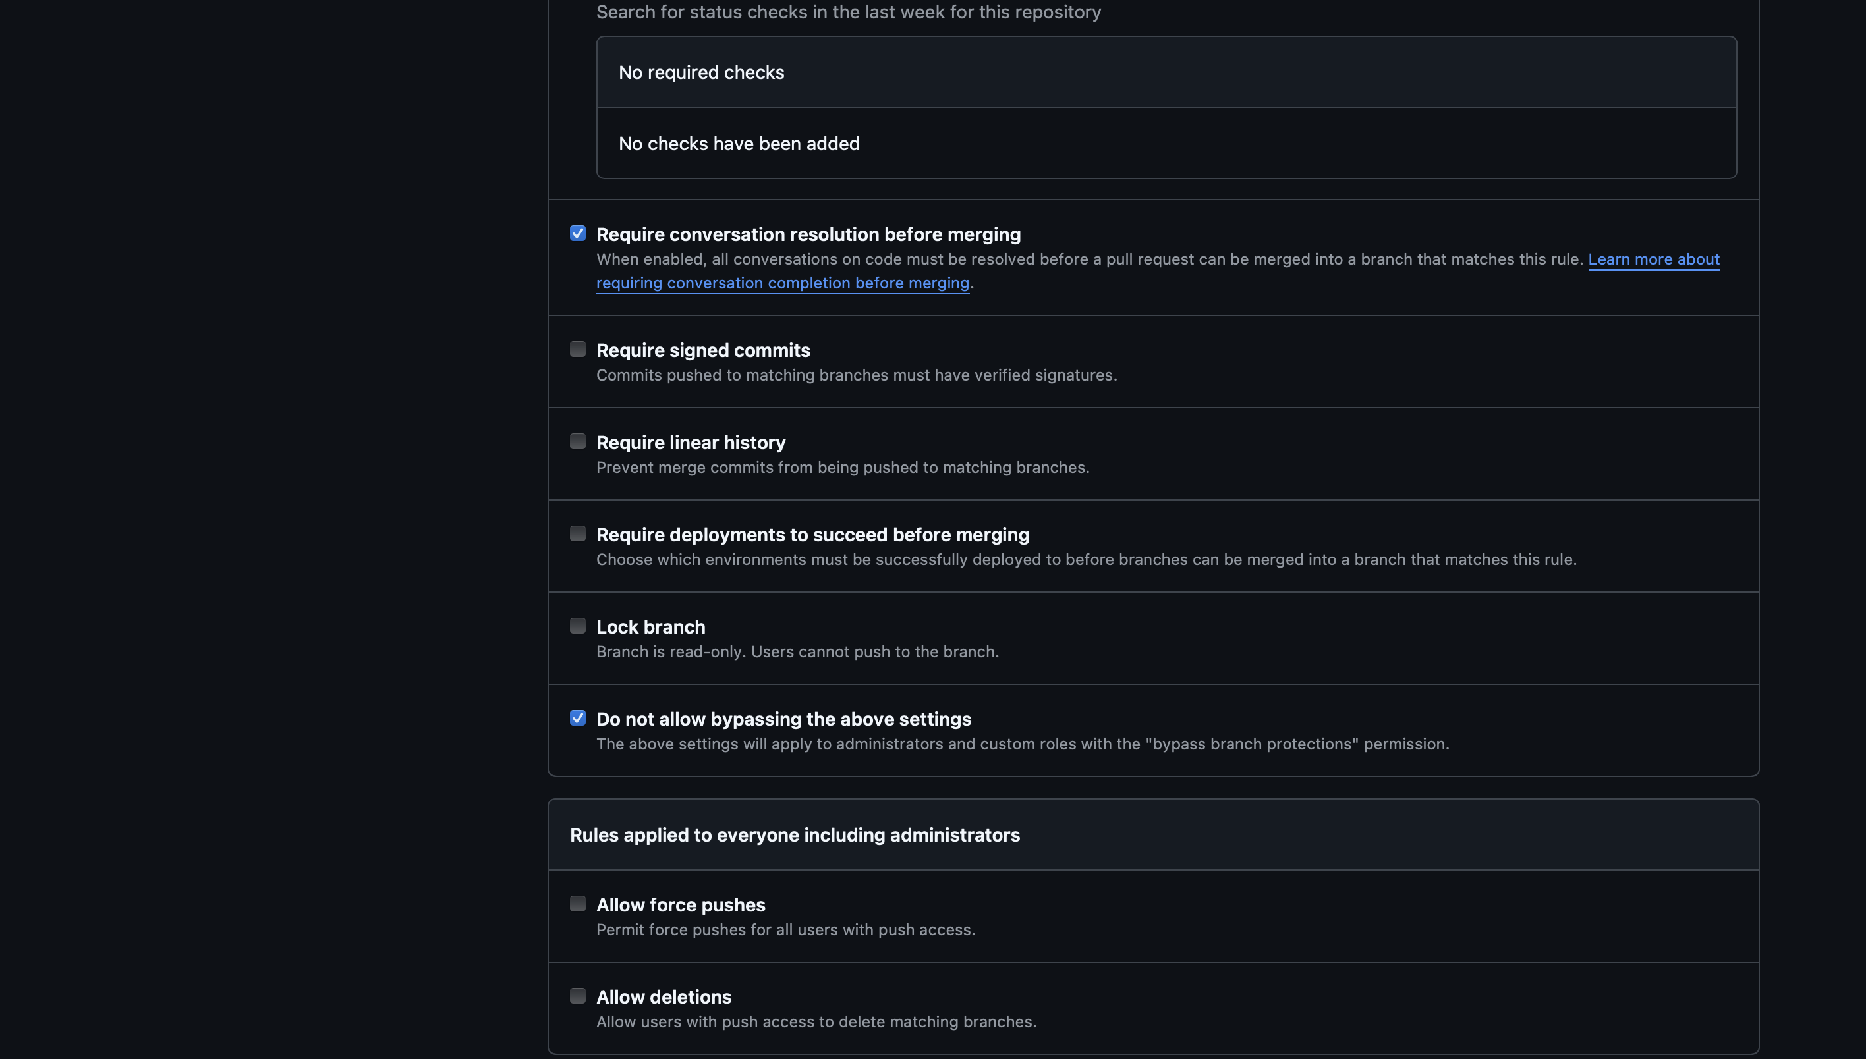
Ci cd diagram + kubescape part + enviroment
Presenting each step manually kubescape configuration.;
installing tools gitleak configuring self host runner
git hook configuration ( pre push)

We started ci cd with gitleaks unfortunatly it didn’t detect secrets passed ..

snyk is op
https://app.snyk.io/org/yassine0010/projects?groupBy=targets&before&after&searchQuery=&sortBy=highest+severity&filters[Show]=&filters[Integrations]=&filters[CollectionIds]=
defectdojo at port 8080
sonarqube at 9000
nexus 8081 bujjed-hyJvas-wynpy6
signing with digest is better blablabla
auto node routing with kyverno -n dev
please don’t forget to update the cv linkedin with new tools

What You Actually Need: Two Separate Things
# | What it is | Purpose
1 | Authentication — proving who the pipeline is | A ServiceAccount + token (or client cert)
2 | Authorization (RBAC) — what that identity is allowed to do | Role + RoleBinding scoped to just the dev namespace

The Actual Plan, Step by Step
1. Create a dedicated ServiceAccount for the pipeline
bash
kubectl create serviceaccount github-actions-deployer -n dev
presenting all tokens we created
explaining the process of rbac pipeline rules and running etc..
Since your RBAC is namespace-scoped (Role/RoleBinding, not cluster-wide), you need two independent ServiceAccounts — one living in dev, one in prod. This is actually good practice: it means a leaked dev token can never be used to touch prod.

How your architecture separates configs:
In

What Each New Step Does, Briefly
Step | Purpose
Install syft | The actual tool that scans an image and generates the SBOM (list of every package/library/version inside it)
Generate SBOM | Runs syft against your signed image, outputs a CycloneDX-format JSON — a standard, widely-supported SBOM format
Attach SBOM with cosign | Stores the SBOM alongside the image in the registry, same mechanism as the signature itself
Sign the SBOM attestation | Cryptographically signs the SBOM too — so someone verifying your image can also verify "this SBOM genuinely came from this pipeline," not just the image itself

image: yassine123432/frontend@sha256:2768222ae074e36e08663f6f5cd9f8bb10b982b6d1f70e0f4111e6a24304b72b we uesd before sha now we use the latest

explaining well detailed of the pipeline each step how he work etc..
in the owasp zap we used the automation framework to test first manually the endpoint auth

port forwording strategie
scan strategie..

What the production Environment Gate Actually Adds
It's a second checkpoint, at a different point in time, checking different things:
add sbom generation in ci cd

setting up kubescape weekly scan and uplod to defect to dojo

Why Port-Forward, Specifically, Here
You already know port-forward creates a temporary tunnel from a specific local port to a service inside the cluster. In this CI job:
yaml
kubectl port-forward -n dev svc/frontend 8081:80 &
- 8081:80 — opens port 8081 on the runner itself, tunneling to port 80 on the frontend Service inside dev
- & — runs it in the background, so the job doesn't hang waiting on this command forever; it keeps running while the next steps execute
Then ZAP, running in a container on that same runner, hits http://localhost:8081 — which now genuinely reaches frontend, thanks to the tunnel.

Installing syft
Generating sbom
Signing with cosign…
Some screens of proof

